**Zscaler APP (ZIA & ZPA)**

Zscaler App simplifies the enforcement of security and policy control from the Zscaler Cloud for both Zscaler Internet Access (ZIA) and Zscaler Private Access (ZPA). Z-App is available for desktop and mobile devices.

Zscaler internet Access ZAP Stable Version 1.4.2.10

Initial Login Screen

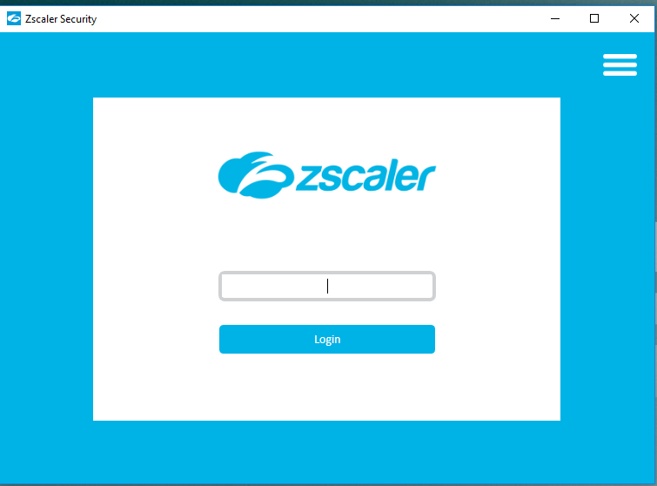

User needs to Login with Email ID or User ID on ZAP

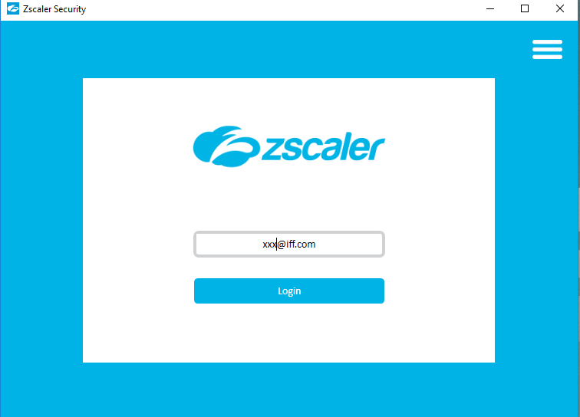

When Users on Office Location SSO will redirection happens, and identify User Details on Okta.

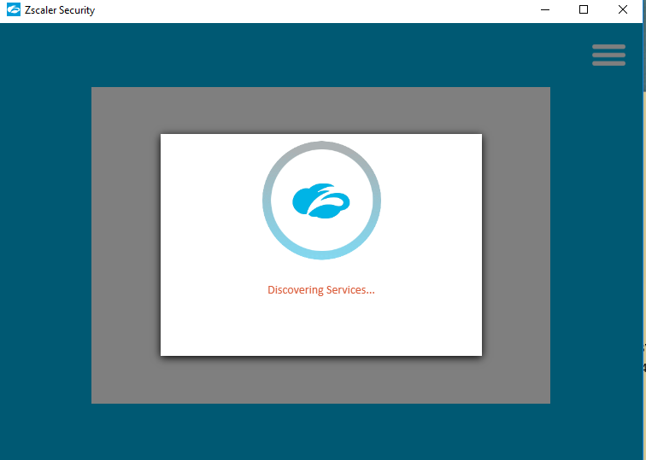

Once its Completed user can Able to access Login ZAP Portal without any issues.

As Global IFF Settings it will have detected Trusted network via reaching Dns server & PAC will be enforce on Zscaler.

User Internet Traffic will be forwarding to GRE Tunnel >>> Zscaler Cloud Datacentre near geolocations.

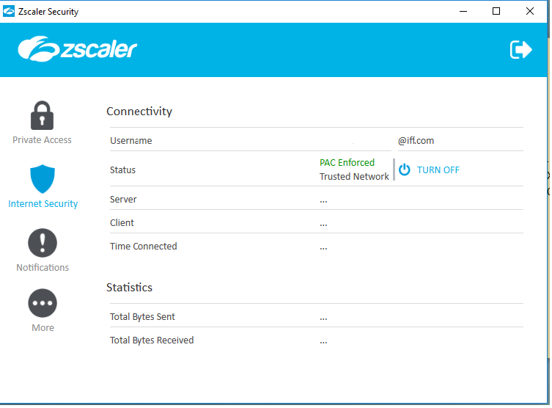

Troubleshooting

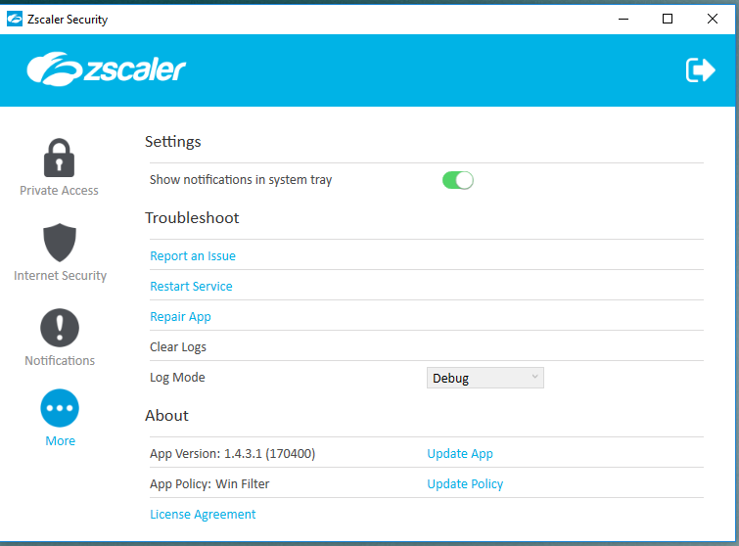

Report an Issues: When users click on Report an Issues Icon Email will triggered to MSP (BT) & IFF Security operations for further Troubleshoot.

User on OFF Network (Out of office or Open internet)

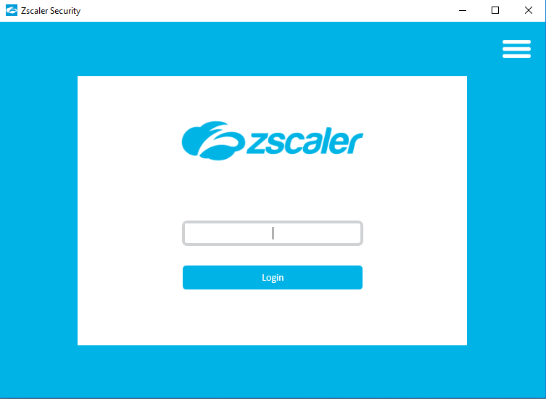

User needs to Login with Email ID or User ID on ZAP



User will have redirected to Okta Page and Need to Complete Multifactor Authentication.

Once user Completed Single Factor Authentication

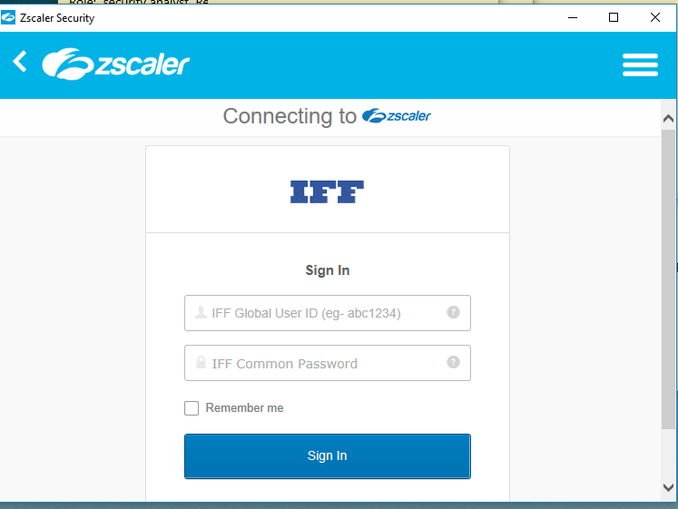

User may need to complete Second Factor Authentication.

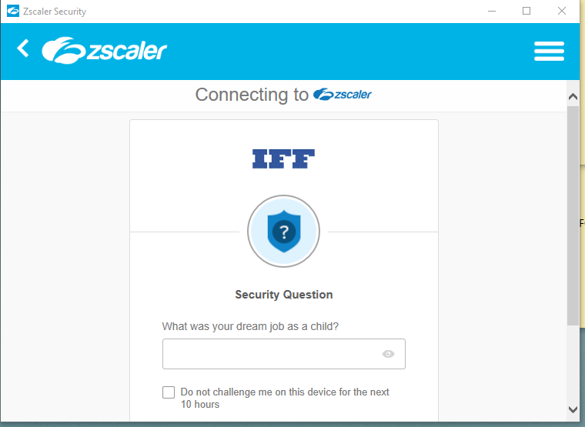

If both Authentication Completed then User will able to access Internet without any issues.

IFF Corporate Internet Policy Will Applicable When User On or Off.

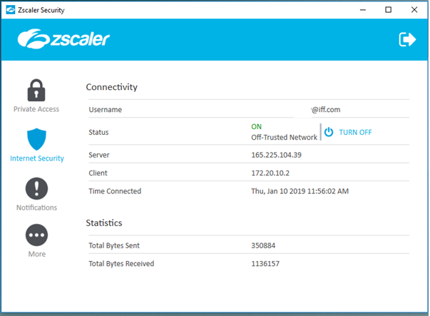

ZAP ZIA Portal Settings

Global IFF Windows Policy

IFF Windows Policy will be applicable for all IFF Users

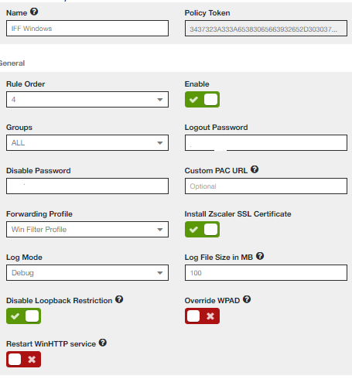

VPN & Okta URLs are bypassed from Zscaler.

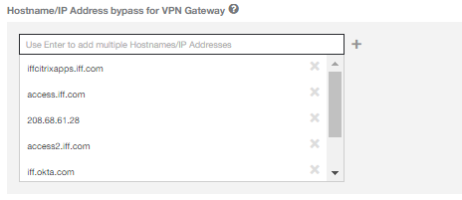

Profile use to identify Trusted or OFF Trusted network

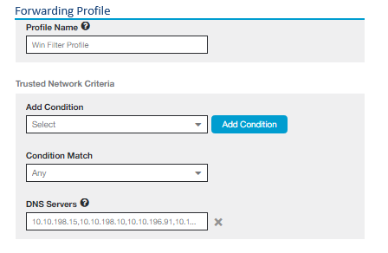

PAC Will be enforced on Zscaler Not on user System.

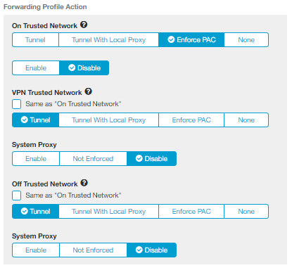

Zscaler Private Access (ZPA Stable Version 1.4.3.1)

To install Zscaler Mobile APP

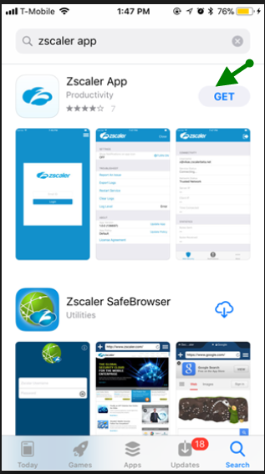

* Open the iTunes store from the device.
* Search for "Zscaler App" in the iTunes store
* Install the Zscaler App

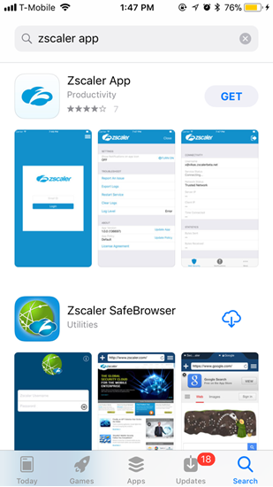

Registering the Zscaler App

1. On the mobile device, open the installed Zscaler App.

2. When it displays the enrolment page, enter the username and tap Login.

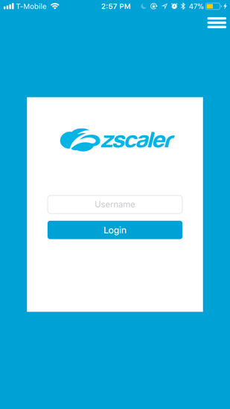

3.Based on your organization's authentication mechanism, you might be prompted to complete one of the following steps:

Simply enter a password and click Login.

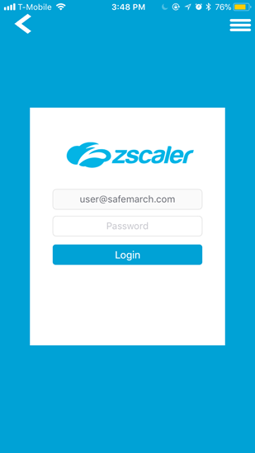

Be redirected to your organization’s SSO form (see example below, in which Okta is the SSO provider). Enter your credentials and log in.

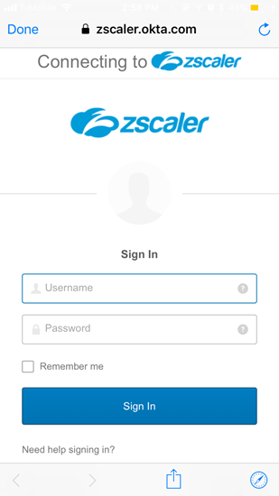

Once Authentication Completed. User able to see on ZAP .

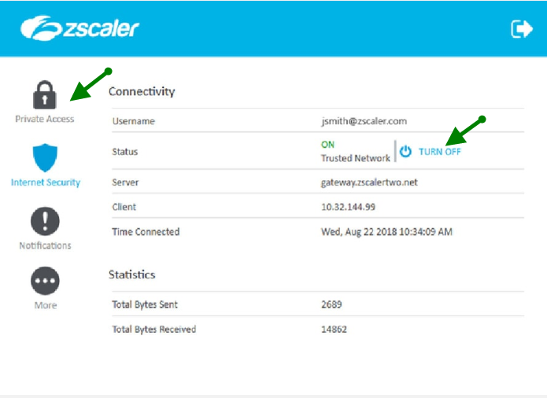

Zscaler Private Access Portal Settings

Infra Rule Configuration for ZAP Mobile users

User should be part of IFF_ZPA_MOB AD group

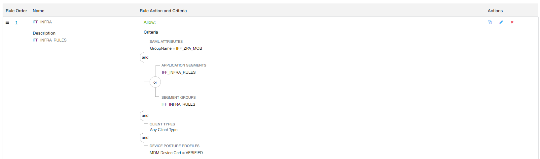

Granular Access Control of SAP Applications

User able to access only SAP Applications

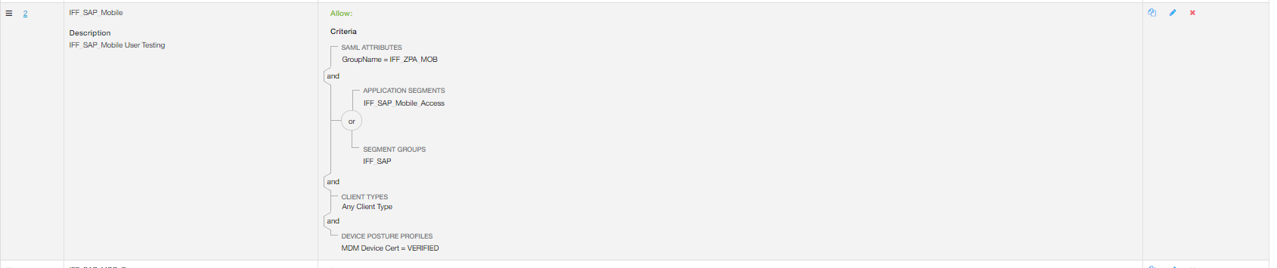

Clean-up Deny Polices .

If users try to access apart from SAP application from Mobiles. Will get deny on Below Policy

